La Nkwantanang-Madina Municipal Assembly Signs Memorandum of Understanding (MOU) with Green Africa Youth Organisation (GAYO) for the Take-Off of Zero Waste Project in the Municipality

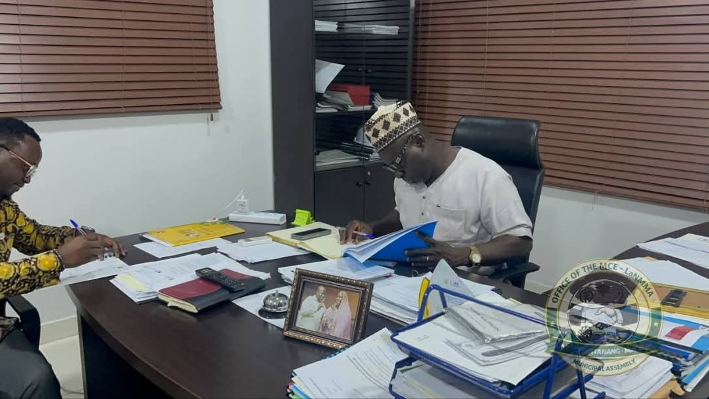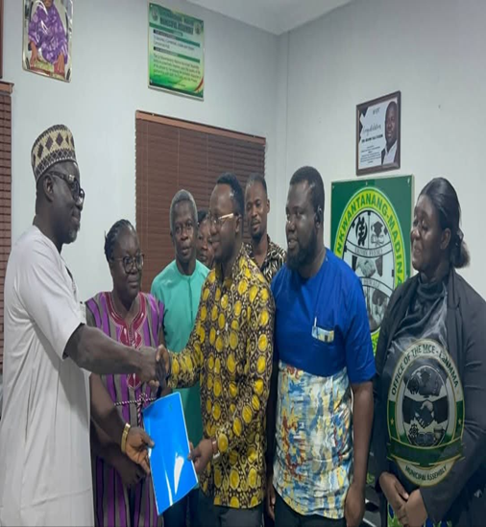
The Management of La Nkwantanang-Madina Municipal Assembly led by Alhaji Ibrahim Faila Fusseini on Wednesday 11th March, 2026 signed a Memorandum of Understanding with Green Africa Youth Organisation (GAYO) - an environmentally inclined Non-Governmental Organisation (NGO) for the implementation of a 5-year Zero Waste for Sustainable Cityscape Project.
The signing ceremony took place in the office of Municipal Chief Executive with the Municipal Co-ordinating Director (Madam Abena Kwesiwa Kyei), the Municipal Environmental Health Officer – Mr. Daniel Anang-Tetteh, the Municipal Planning Officer (Pln. Frederick Asiamah) and other Management members representing the Assembly. In attendance for Green Africa Youth Organisation were four management members spearheaded by Mr. Richard Matey (the Executive Director).
The project aims at enhancing waste management systems, reducing air pollution, promoting community awareness and fostering sustainable development. As part of its contribution to the project, the Assembly is required under the MOU to allocate suitable land space for the establishment of Material Recovery Facility, urban demonstration garden as well as facilitation of approval processes for the operation of the project. GAYO on the other hand is expected to provide the required expertise and resources to make the project a reality.
In a brief statement, the MCE indicated his excitement at the commencement of the project following series of engagement with the leadership of GAYO. He pledged the full support of management of to the Assembly to the successful roll-out of the project. He emphasized the potential of the project in helping the Assembly to initiate the much-touted waste segregation, reduction in the cost of managing waste and above all, creation of job opportunities for residents of the Municipality particularly the youth.
The Management of GAYO commended the Assembly for the partnership and indicated its readiness to hit the ground running with the planned implementation activities. Management of GAYO further assured the Assembly of a copy of the implementation schedule in order to get relevant Management staff of the Assembly and other stakeholders actively involved in the delivery of the project. To ensure effective co-ordination of the project implementation process, the Municipal Environmental Officer was nominated by Management of the Assembly as the Schedule Officer to be assisted by the Municipal Planning Officer. The Assembly is eternally grateful to GAYO and the funders, and looks forward to effective execution and realization of the project objectives.

