LaNMMA Inaugurates HIV and AIDS Committee
The La Nkwantanang-Madina Municipal Assembly has inaugurated a 12- member HIV and AIDS to promote public health and collaborative action toward an HIV- free society on Friday, April 24, 2026 at the Assembly Hall.
The 12-member committee is chaired by Hon. Ibrahim Faila Fusseini, others are Dr. Efua Commeh, Municipal Health Director; Juliana Kwapong, representing PLHIV, Ms. Felicia Sosu, an NGO rep; Rev. Akass Jacobson, Christian rep; Rev. E. D Niikoi, Traditional rep.
The rest includes Muniru Abubakar, Moslem rep; Ms Bridget Adzar Zoya, MHD_TB Co-ordinator; Love Amoabeng, Social Welfare; Diana Asempah, GES SHEP Cordinator; Vida W. Agoriwo and Mama Setriakor Wovenu.
The occasion brought together officials of the assembly, stakeholders, health representatives and other key relevant personalities in the scheme of things.
In his inaugural speech, Mr. Deric Oppong- Agyare, Deputy Director of Programs Ghana AIDS commission said the inauguration of the committee marks an important step in strengthening institutional efforts to combat HIV and AIDS in the municipality.
Swearing in the members into office, the Municipal Magistrate Judge, her Lordship Rose Abena Gyimah emphasized the importance of the committee’s mandate in collaborating and strengthening local responses to HIV and AIDS prevention, awareness creation, treatment support and advocacy within the Municipality.
The Chairman of the occasion and Municipal Chief Executive, Hon. Ibrahim Faila Fusseini expressed his profound gratitude to the inauguration team and the technical partners from the Ghana AIDS Commission and Greater Accra Regional Coordinating Council.
He highlighted the critical role of the committee to promoting multi-sectorial collaboration to address HIV and AIDs- related issues and reduce stigma and discrimination.
He urged members to work diligently and with commitment to support the implementation of policies and programs aimed at improving the wellbeing of residents.
The newly inaugurated members expressed their readiness to serve and pledged to work collectively to achieve the objectives of the committee in line with nationalize and municipal development priorities.

PHOTO GALLERY OF THE INAUGURAL CEREMONY 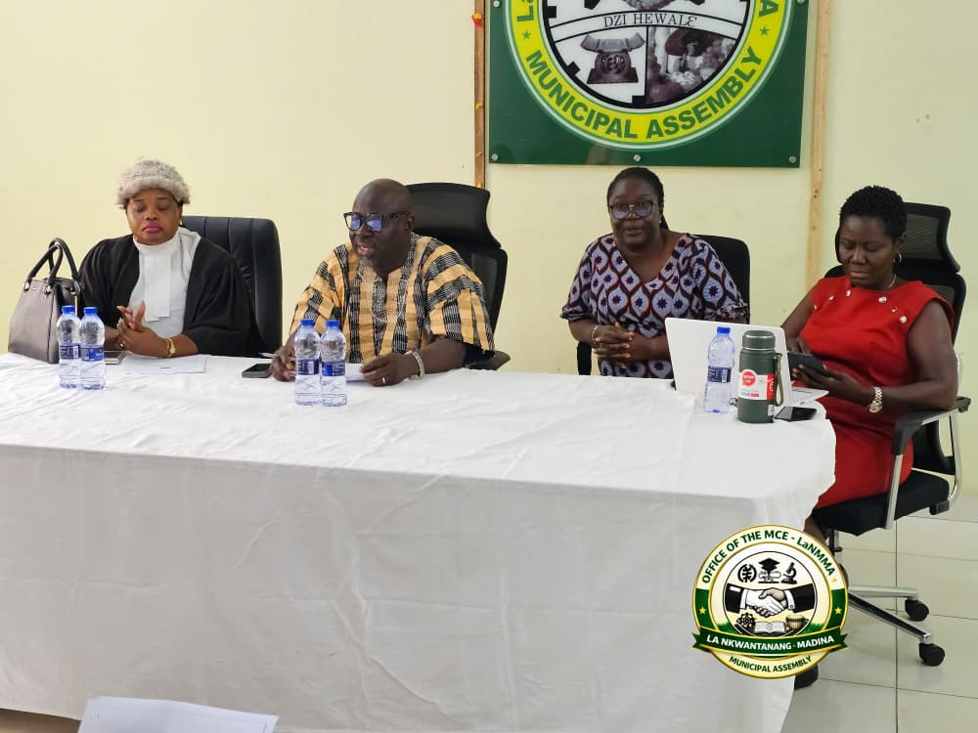
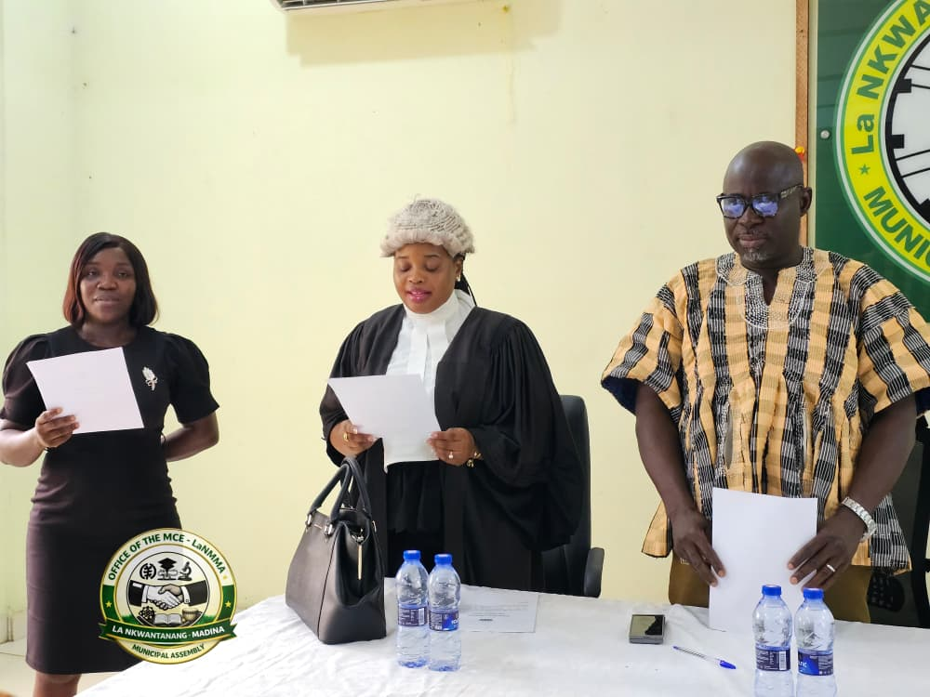
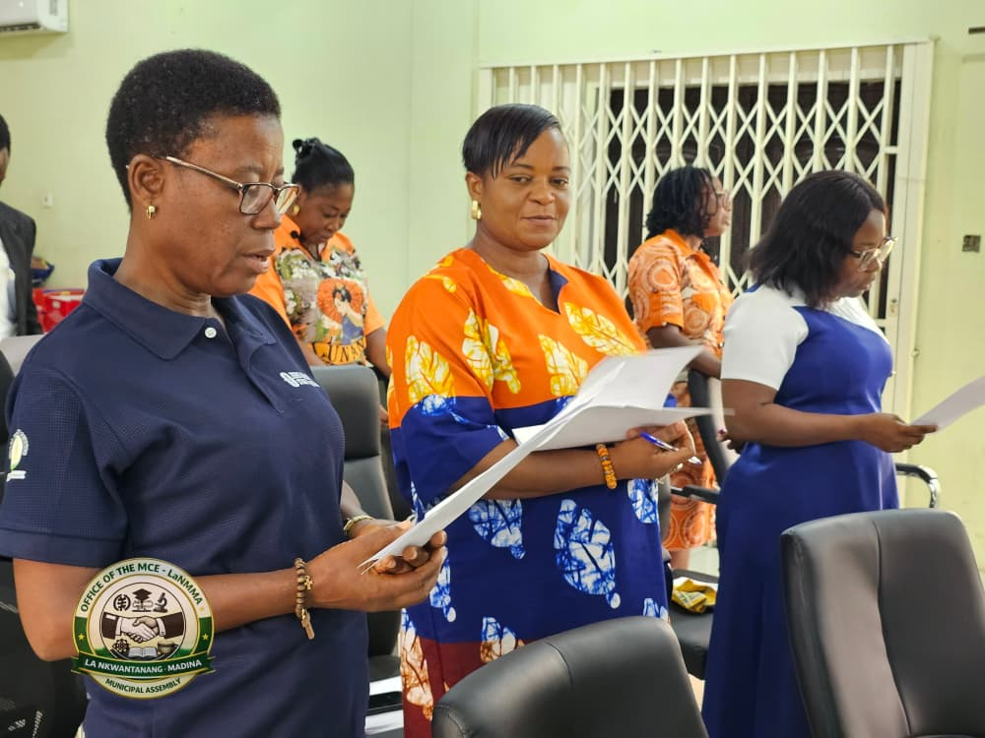

SOURCE: ISD-LaNMMA

