La Nkwantanang-Madina Municipal undertakes giant steps to boost education
In a conscious effort to boost education delivery outcomes, the La Nkwantanang Madina Municipal Assembly has embarked on major educational infrastructure projects and supply of educational materials for basic and second cycle schools.
These include 1000 mono desks to Senior High Schools as well as Technical and Vocational Education and Training Schools within the municipality.
The assembly also has plans afoot to purchase and distribute 540 furniture for KG schools.
Furthermore, during the course of this year, the assembly also plans to procure and distribute 180 sets of furniture for teachers which would be made up of a table, a teacher’s chair and two visitors.
This came to light when the Municipal Chief Executive Hon. Ibrahim Faila Fusseini delivered the sessional address at the First Ordinary Meeting of the Third Session of the Fourth Assembly on Thursday, 22nd April 2026.
Other key infrastructure projects being undertaken include construction of community clinic and two bedrooms teacher’s bungalow both at Baba Yaro, and construction of an 18 –unit classroom block at Pantang among others.
Additionally, the Education Directorate of the Assembly has organized a number of capacity building workshops for School Improvement Support Officers, Head teachers and all teachers at the Kindergarten, Primary and JHS levels to enhance lesson delivery in the schools.
On health, he said the Municipal Health Directorate of the Assembly is actively engaged in health promotion, disease surveillance, immunization programs, maternal and child health, effective data management and other public health activities in accordance with its mandate to improve the health and well-being of the populace within the municipality.
On roads, he mentioned that, among the road construction currently ongoing within the Municipality include rehabilitation of Redco roads, Teiman Area, Pentecost Hospital area roads and resealing of selected.
He said the success of the Assembly depend on the level of cooperation exhibited by inhabitants and staff altogether, urging all to work towards a common goal.
In a related development, Hon. Abdul Razak Cisse was retained as a Presiding Member through popular acclamation at last Thursday’s sitting and was subsequently sworn into office by Her Lordship Rosemary Abena Gyimah.

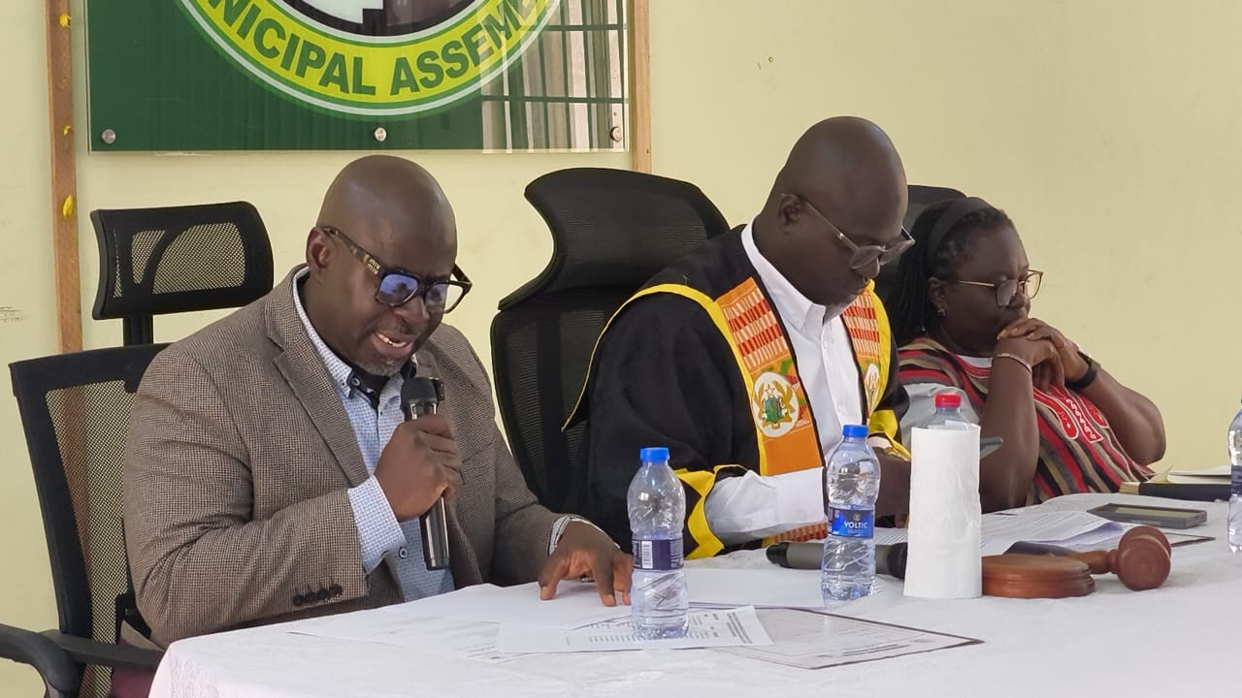Hon. Fusseini (left) delivery his address at the General Assembly meeting

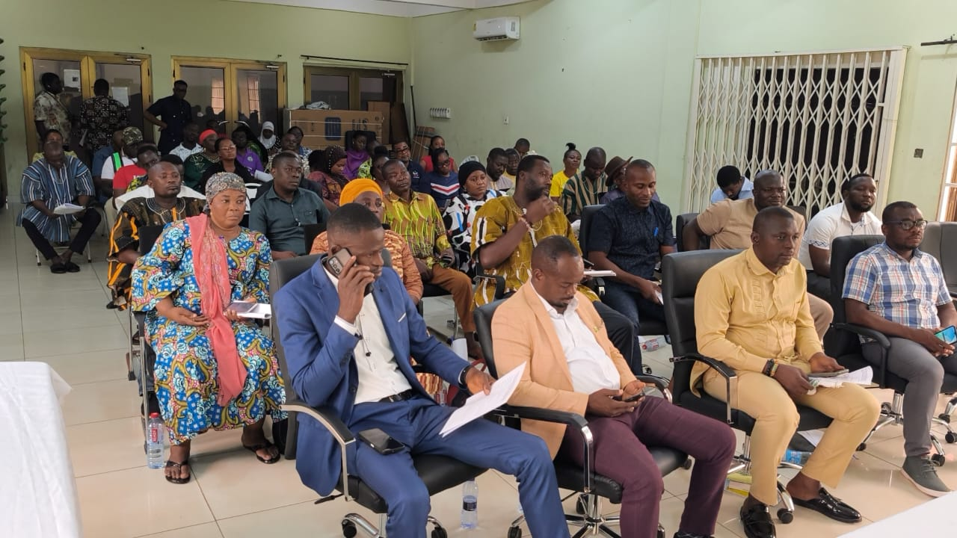Hon. Assembly members and Heads of department at the meeting

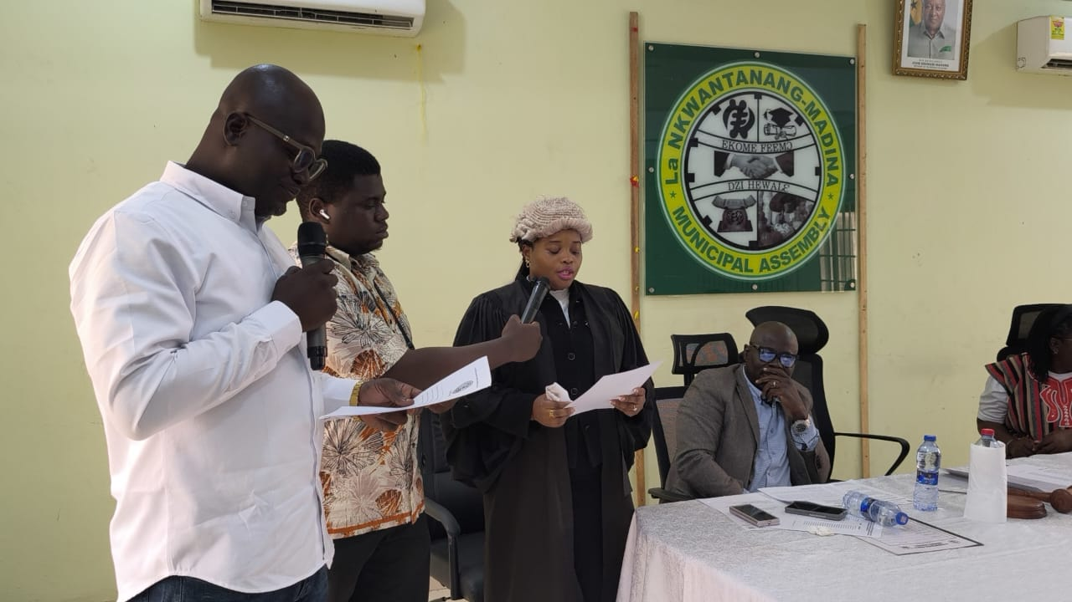Her Lordship Rosemary Abena Gyimah administering the oath of office to Hon. Abdul Razak

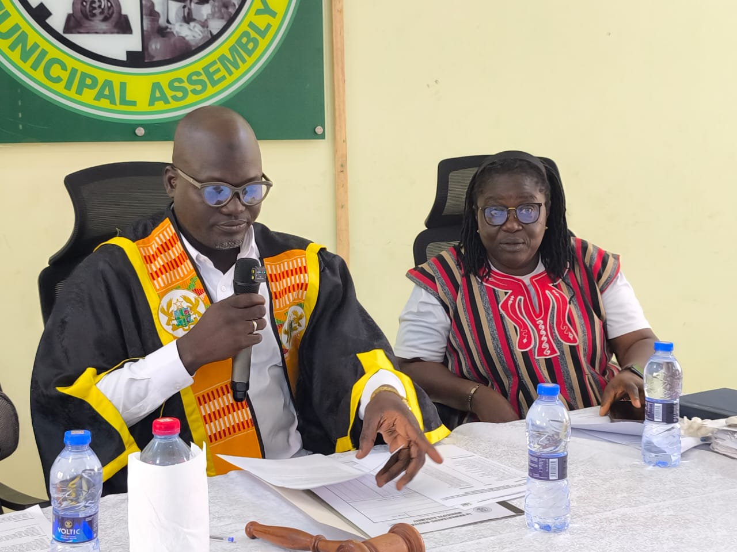Hon. Abdul Razak (left) reading his acceptance speech, seated right is Madam Kyei, the MCD

SOURCE: ISD-LaNMMA

