LaNMMA staff undertake clean-up exercise ahead of national sanitation campaign
Staff of the La Nkwantanang-Madina Municipal Assembly (LaNMMA) on Thursday embarked on a two-hour clean-up exercise at the Assembly's premises ahead of the nationwide general cleaning exercise scheduled for Friday, July 10, and Saturday, July 11, 2026.
The exercise, led by the Municipal Coordinating Director (MCD), Madam Abena Kwesiwa Kyei, formed part of efforts to prepare the Assembly for the national sanitation campaign while demonstrating leadership in environmental cleanliness.
The staff cleared overgrown weeds, swept the compound, desilted gutters and removed refuse and other debris from choked drains within the Assembly's premises.
Addressing the staff after the exercise, Madam Kyei urged them to commit themselves fully to the two-day national clean-up exercise, stressing the need to lead by example.
She said the Assembly's internal clean-up exercise was intended to send a clear message to residents and other stakeholders that the national sanitation campaign was an important initiative that required the support of all.
"We are using this morning's exercise to tidy up our premises to send a strong signal to all and sundry that tomorrow's exercise should not be taken for granted," she said.
Madam Kyei called on residents, institutions and businesses within the municipality to actively participate in the national exercise to help improve environmental sanitation and promote public health.
The nationwide clean-up exercise is expected to mobilise citizens across the country to clean their communities, clear drains and gutters, and ensure proper waste disposal as part of efforts to create a cleaner and healthier environment.
Moments from Our Clean-Up Exercise
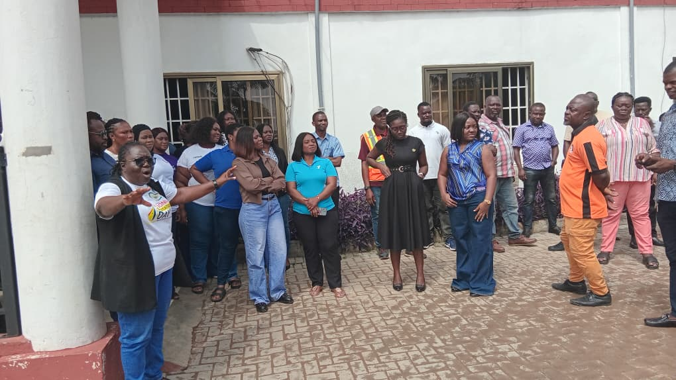
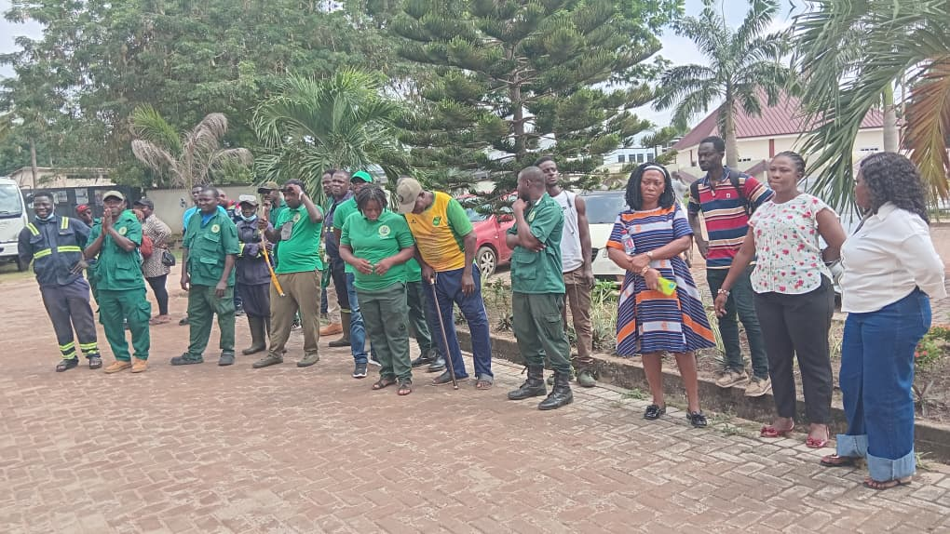
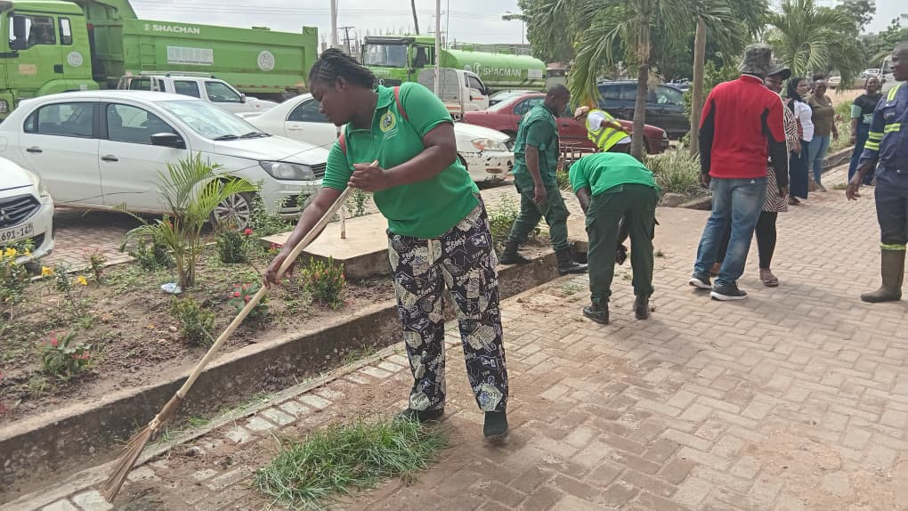

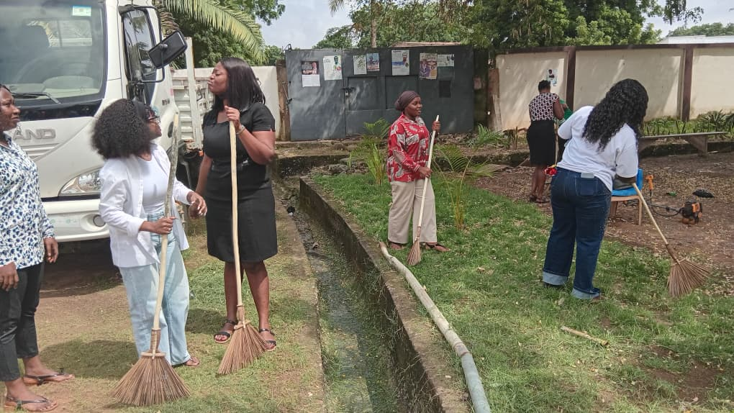

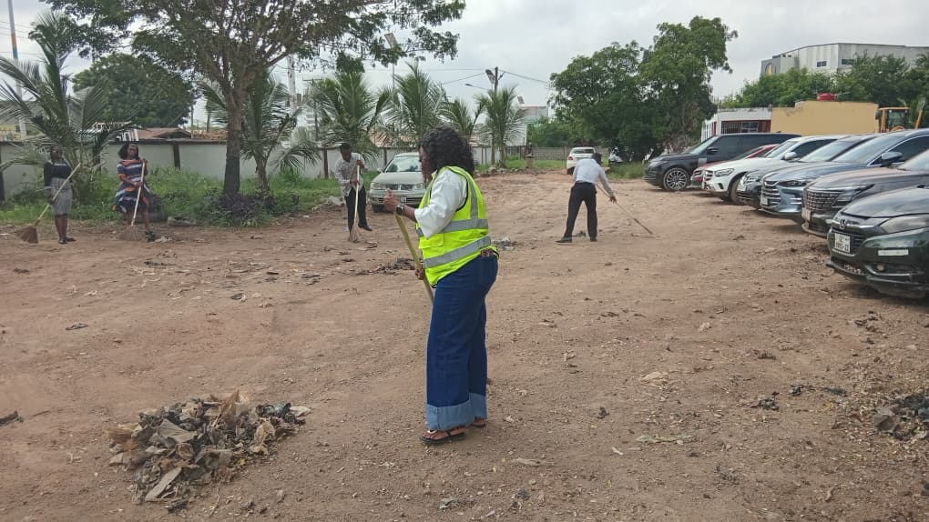
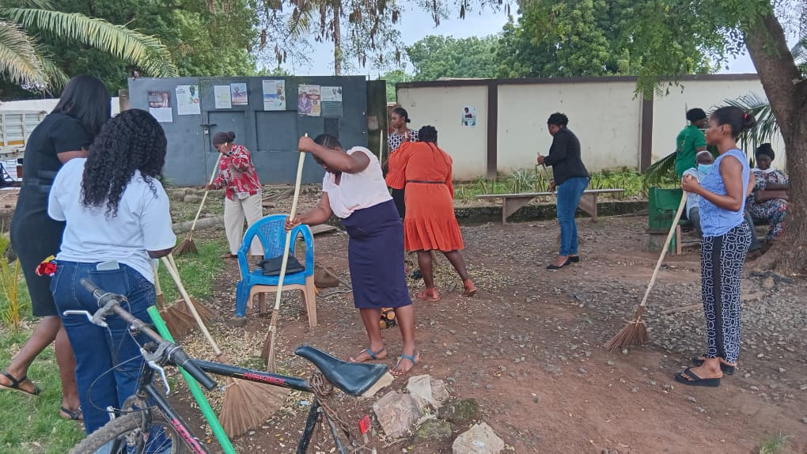
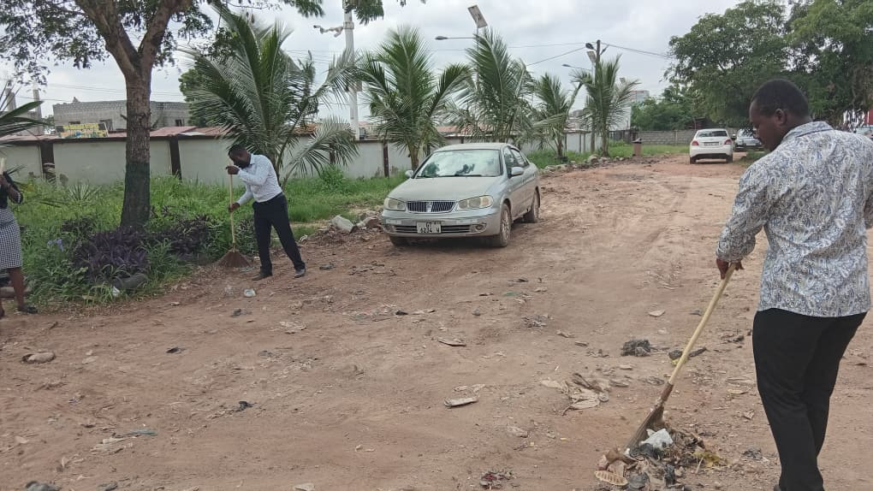

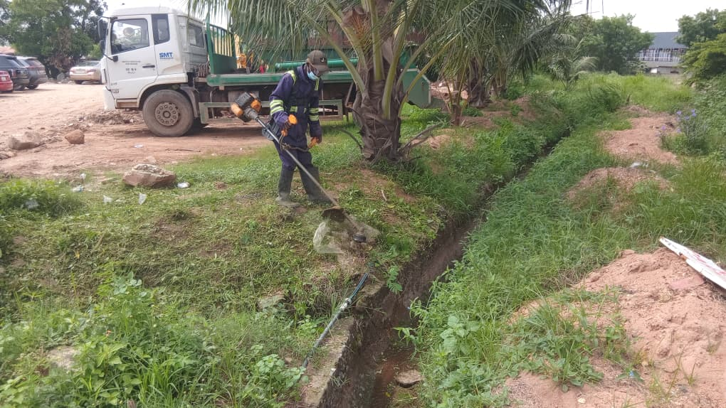

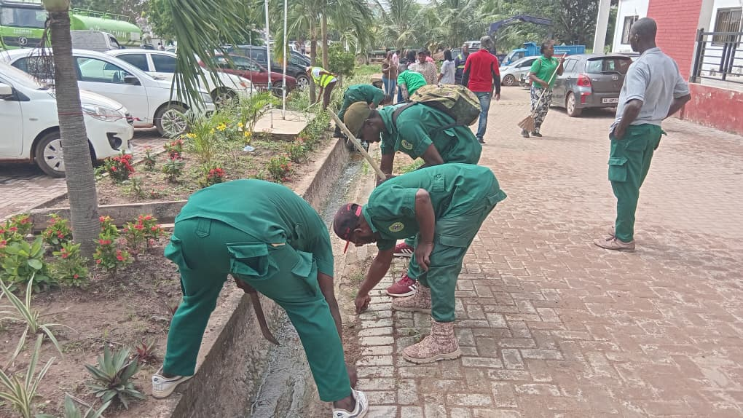

Source: ISD-LaNMMA

