LANMMA Holds National Prayer and Thanksgiving Service, Calls for Collective Fight against Corruption
The La Nkwantanang-Madina Municipal Assembly (LNMMA) on Wednesday held its National Prayer and Thanksgiving Service at the Rehoboth Baptist Church, Ayi Mensah, with a call on Ghanaians to join efforts to combat corruption and other social vices.
Preaching on the theme, "Resetting Our Values to Build the Ghana We Want," the Minister in Charge of the church, Rev. Asiedu-Appiah, urged Ghanaians to be courageous and patriotic, as reflected in a section of the national anthem.
Basing his sermon on Psalm 11:3, he said the fight against corruption required the collective efforts of all citizens, stressing that the Government alone could not eradicate the menace.
Rev. Asiedu-Appiah noted that social vices such as illegal mining (galamsey), corruption, bribery, and other forms of misconduct continued to undermine the country's development and moral values.
He appealed to Ghanaians to support government efforts by upholding integrity, accountability, and ethical conduct in their homes, workplaces, and communities.
In his remarks, the Municipal Chief Executive for La Nkwantanang-Madina, Mr. Ibrahim Faila Fusseini, assured residents that the Assembly remained committed to implementing policies and programmes aimed at improving their living conditions.
He reaffirmed the Assembly's determination to promote sustainable development through the provision of quality infrastructure and essential social services to enhance the well-being of residents.
The event brought together officials of the Assembly, religious leaders, traditional authorities, security personnel, and members of the public to offer prayers for peace, unity, and national development.
Highlights of the National Prayer and Thanksgiving held at the Rehoboth Church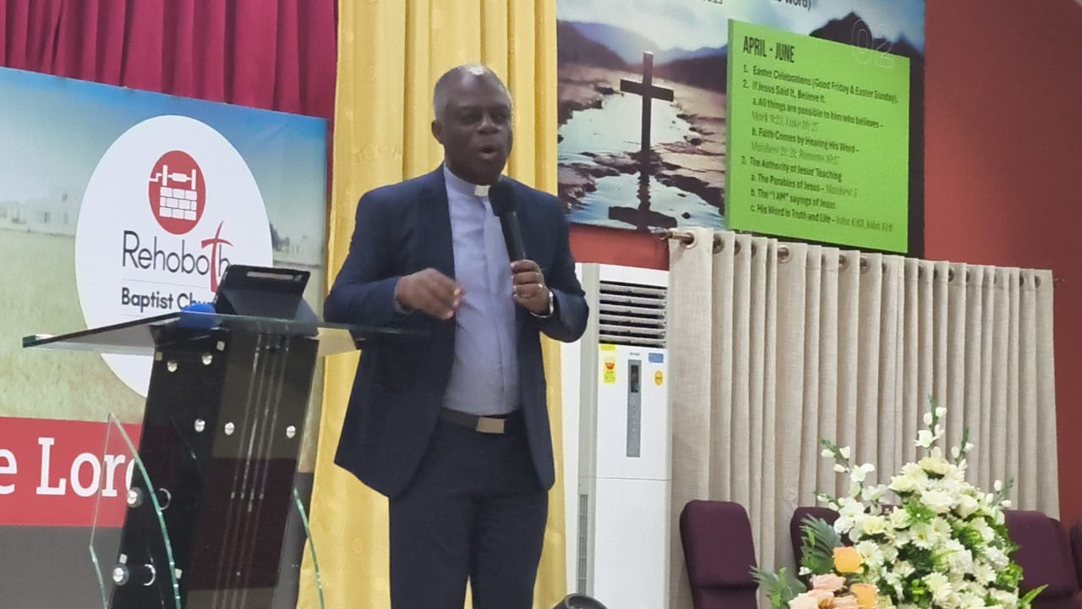
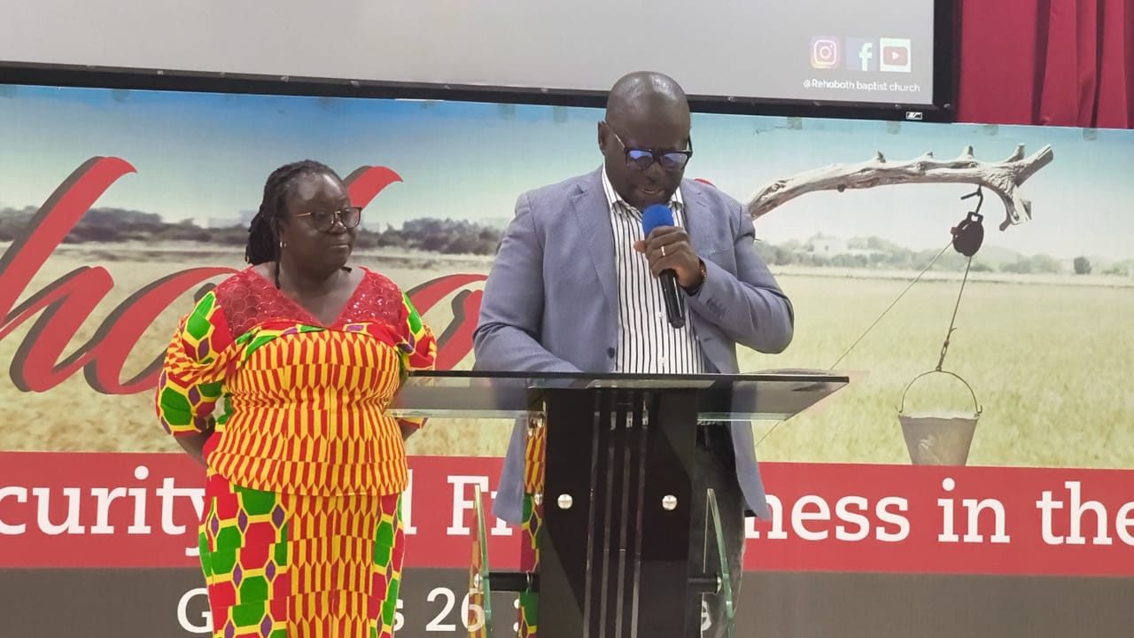

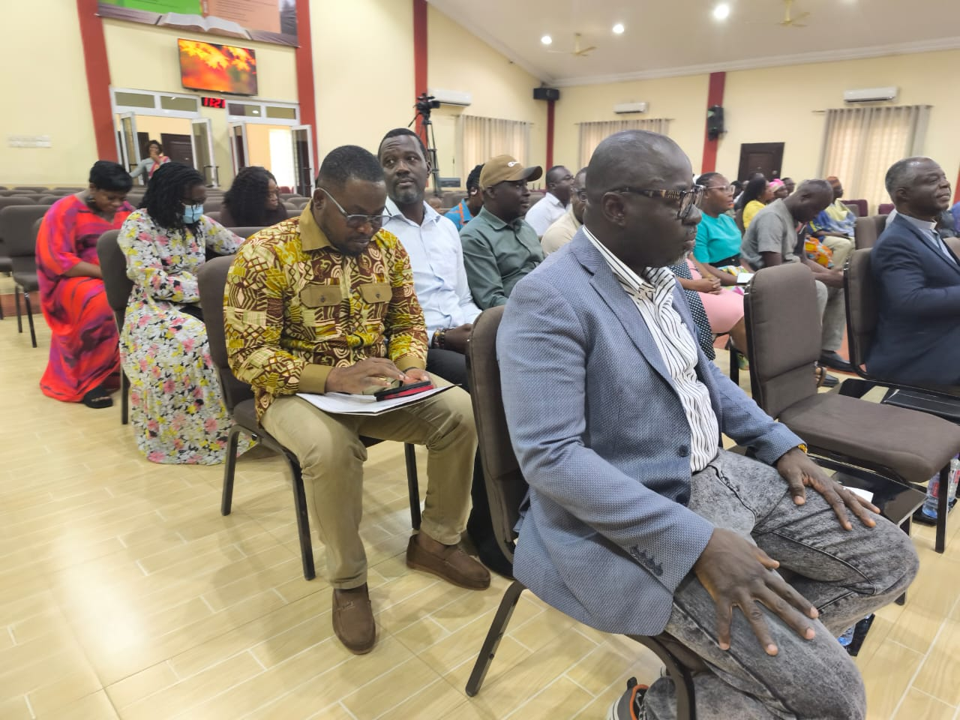

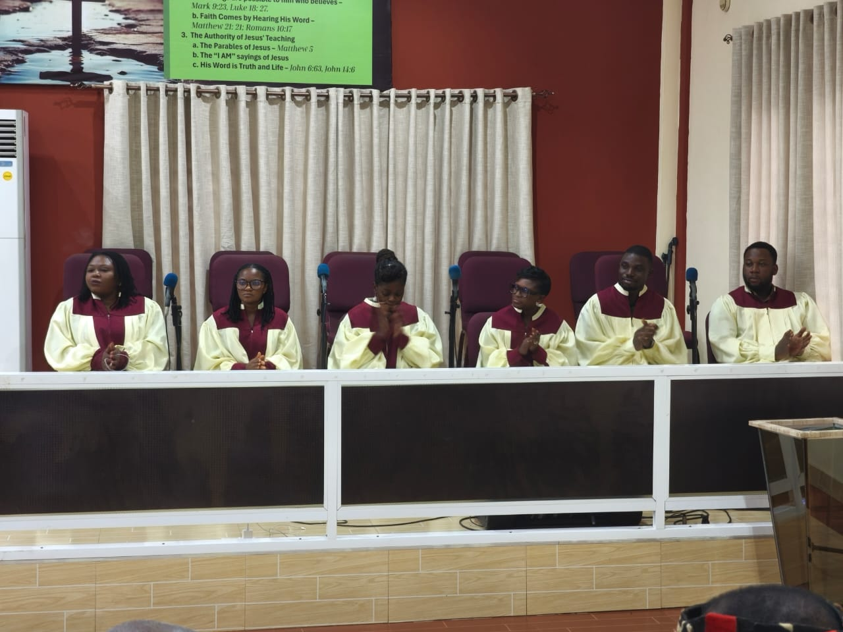
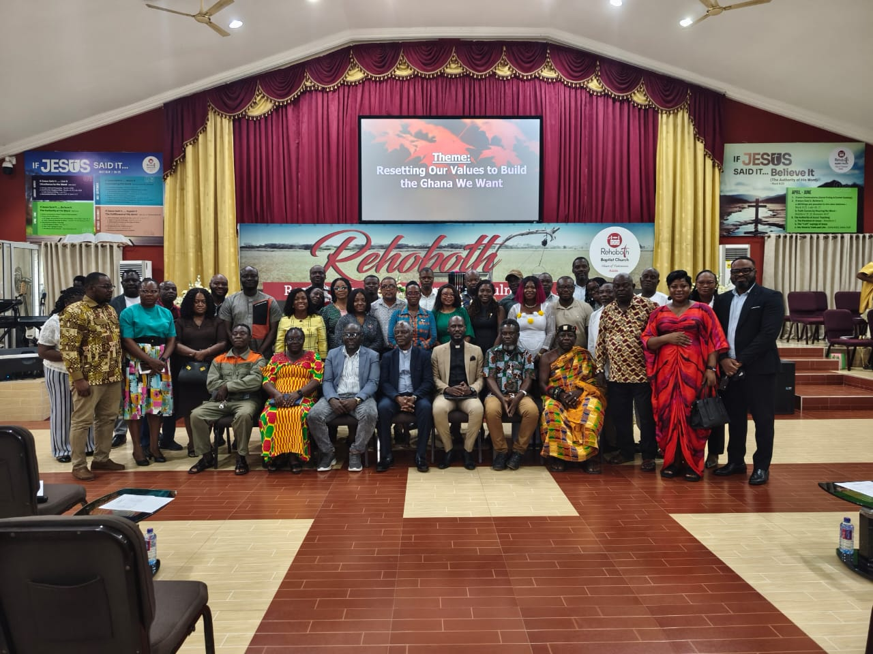

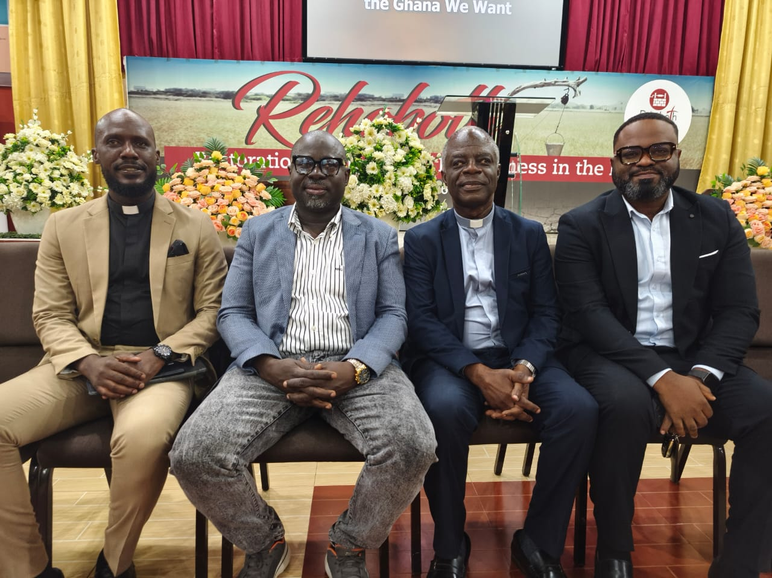

SOURCE: ISD-LaNMMA

