La Nkwantanang-Madina Assembly Undertakes Massive Clean-Up Exercise to Promote Environmental Sanitation
The La Nkwantanang-Madina Municipal Assembly (LaNMMA) has successfully undertaken a large-scale environmental clean-up exercise across the Municipality as part of the National Sanitation Days initiative aimed at preventing flooding and improving public health.
The two-day exercise, which commenced at 6:00 a.m., attracted an impressive turnout of residents and stakeholders who joined forces to clear drains, desilt choked gutters, remove overgrown weeds, and sweep refuse from major streets and public spaces.
Participants included traders, students, security personnel, and staff of the National Disaster Management Organisation (NADMO), cadet corps from second-cycle institutions, Zoomlion Ghana Limited staff, Assembly staff, community volunteers, and residents.
The clean-up exercise was in response to a directive by the President of the Republic designating July 10 and 11 as National Sanitation Days to facilitate the clearing of drains and reduce the risk of flooding following recent heavy rains that caused significant destruction in parts of the country.
The Municipal Chief Executive (MCE), Hon. Ibrahim Faila Fusseini, welcomed participants and joined them in the exercise, demonstrating the Assembly's commitment to maintaining a clean and healthy environment.
By 8:00 a.m., significant progress had been made, with long stretches of drains cleared of silt and waste. Large heaps of debris had been gathered for evacuation, while overgrown vegetation had been cut back and refuse removed from public areas.
Speaking to the media during the exercise, Hon. Faila Fusseini noted that although the Assembly routinely organises sanitation exercises, the National Sanitation Days initiative provided an opportunity to intensify efforts to keep the Municipality clean and resilient against flooding.
He stressed that environmental cleanliness is a shared responsibility and announced that the Assembly would enforce sanitation regulations to ensure sustained compliance by residents.
"The sanitation campaign is here to stay, and we will not hesitate to apply the law against anyone who disregards the municipality's sanitation by-laws," the MCE stated.
Addressing concerns about the disposal of the waste collected during the exercise, Hon. Faila assured the public that adequate arrangements had been made, indicating that all refuse and debris would be transported to the Kpone Landfill Site for proper disposal.
The Municipal Assembly has therefore urged all residents to support the ongoing sanitation campaign by maintaining clean surroundings, desisting from indiscriminate dumping of waste, and complying with environmental sanitation regulations to build a cleaner, healthier, and flood-resilient municipality.
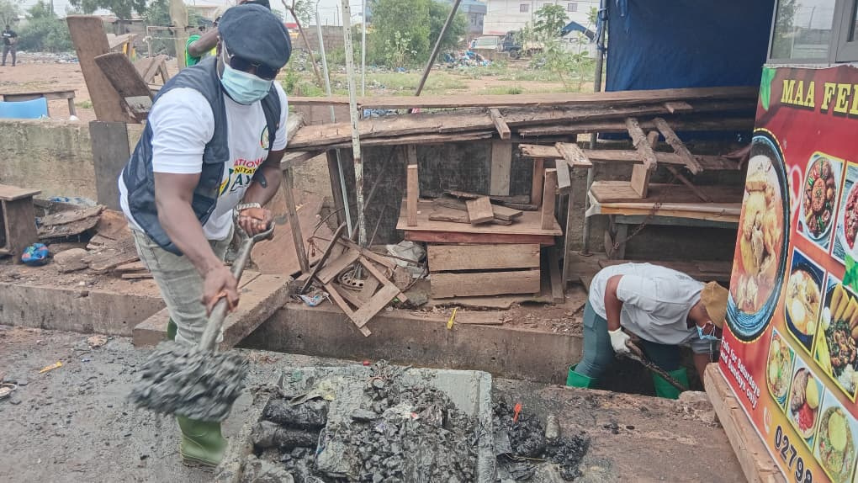
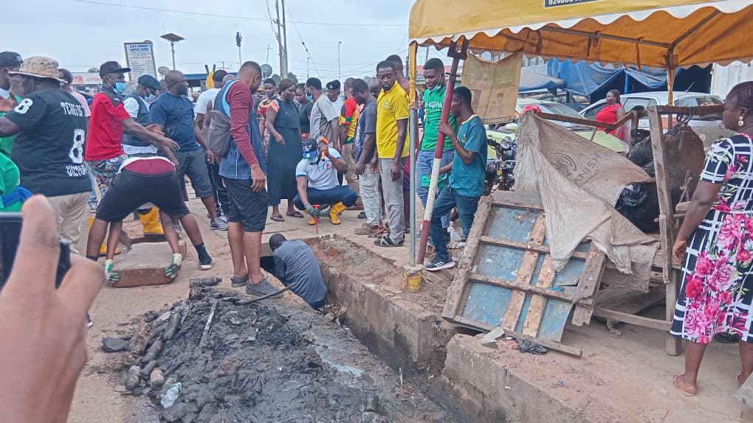

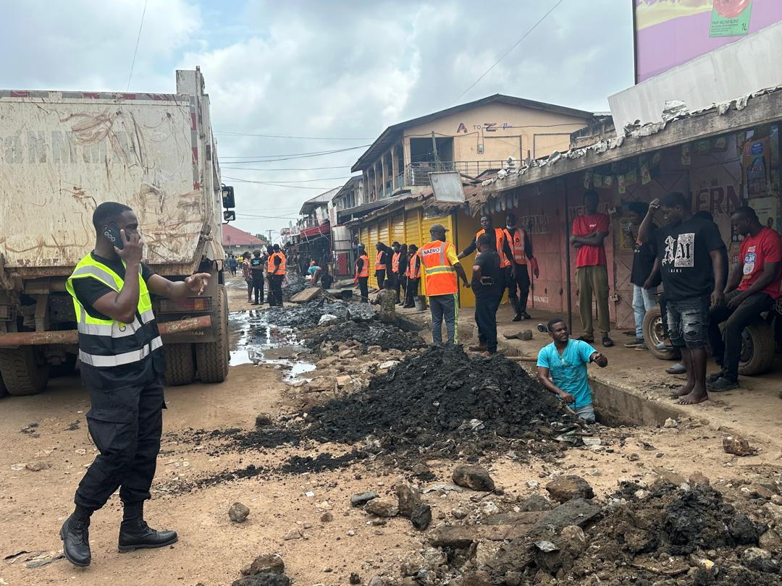
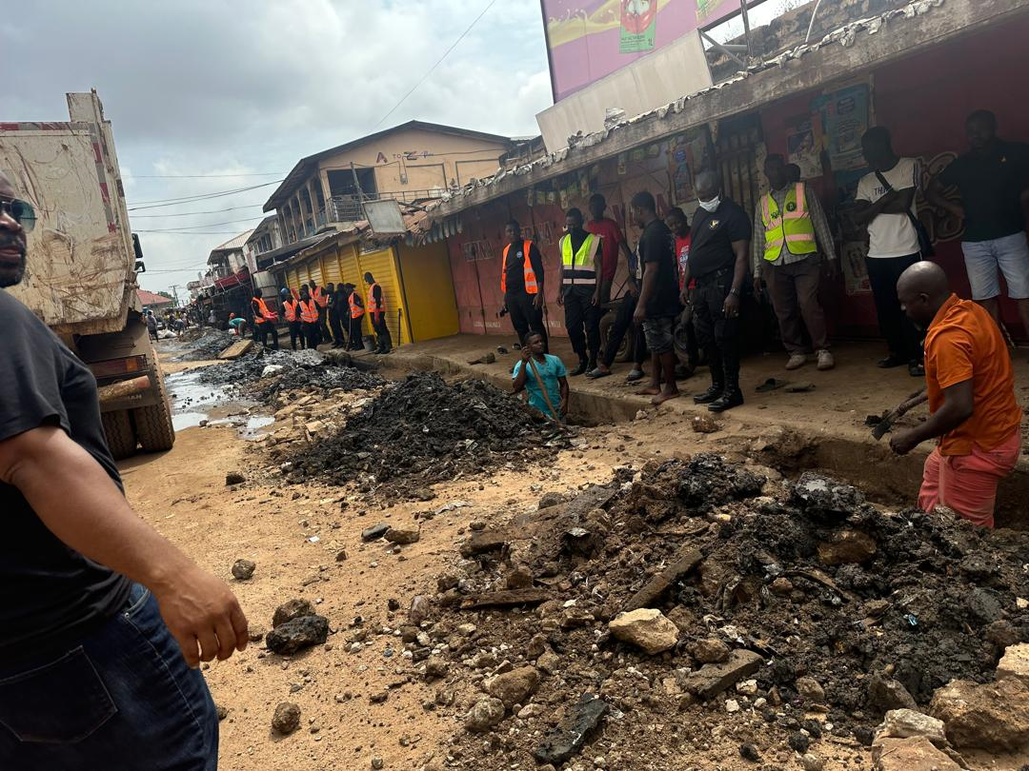
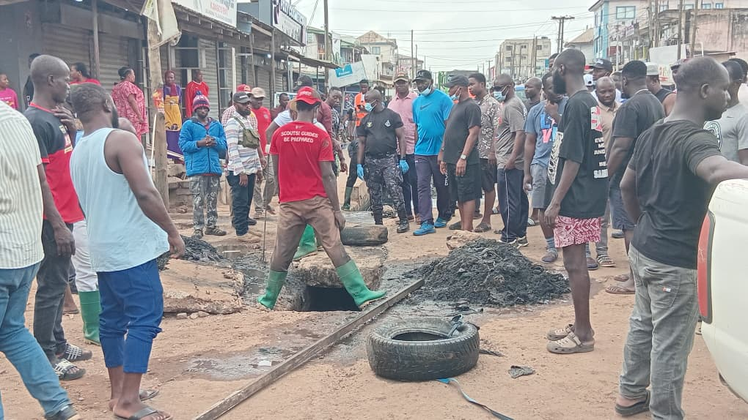

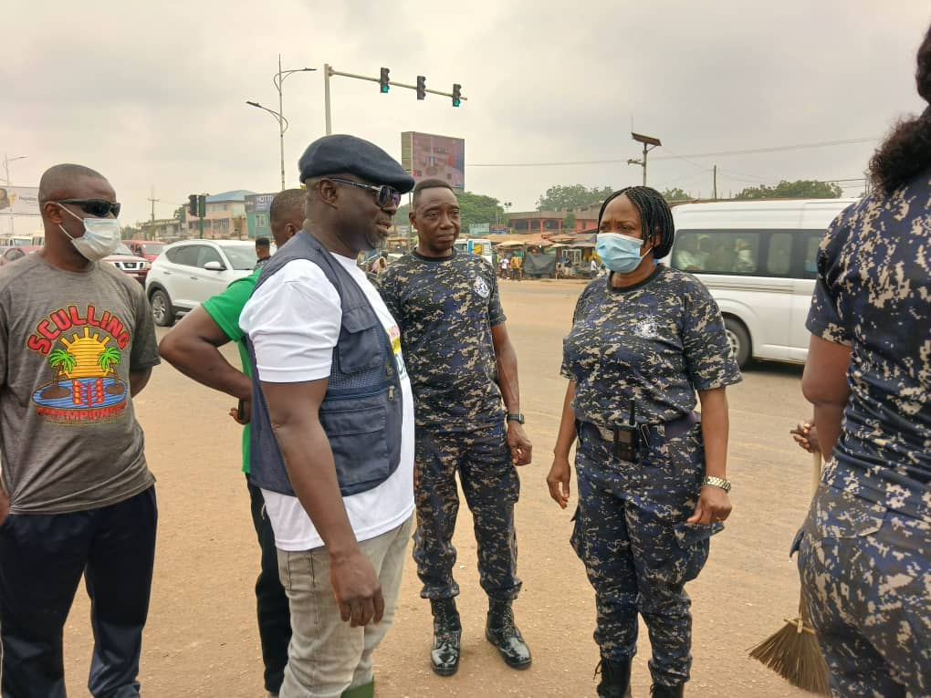
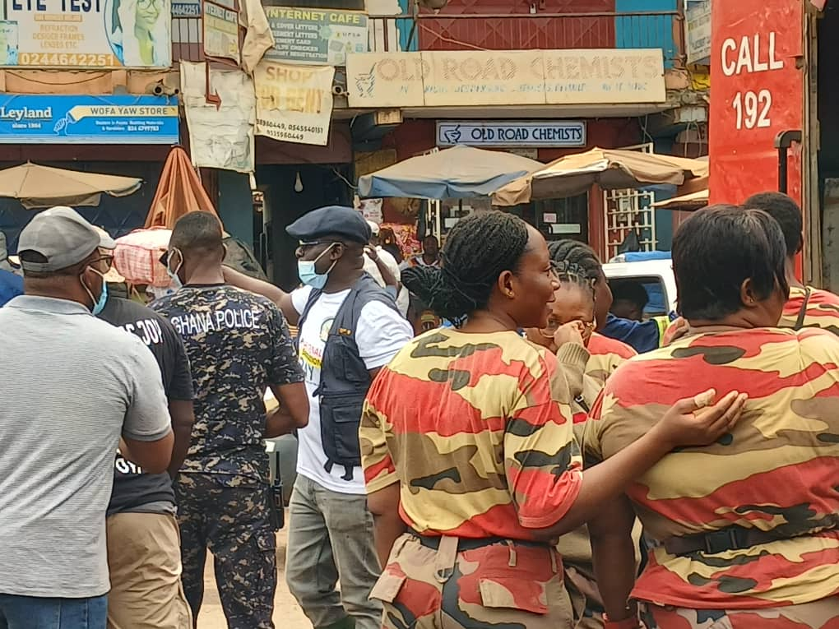

SOURCE: ISD-LaNMMA

