Local Government Minister Commends Madina Municipality After Nationwide Clean-Up Exercise
The Minister for Local Government, Chieftaincy and Religious Affairs, Hon. Ahmed Ibrahim, has commended residents of the La Nkwantanang-Madina Municipality for their active participation in the nationwide clean-up exercise, describing the municipality's sanitation conditions as impressive.
The Minister made the remarks during a post-clean-up inspection tour of selected municipalities on Wednesday, July 15, to assess the impact of the official two-day nationwide clean-up exercise held on July 10 and 11, 2026.
In the La Nkwantanang-Madina Municipality, Hon. Ibrahim inspected several busy locations, including Melcom Road, Madina Zongo Junction, the VRA Lorry Park and Baaba Seidu Road.
At Melcom Road, the Minister observed ongoing desilting of major drains aimed at preventing flooding during the rainy season. He later visited the VRA Lorry Park, where sanitation workers were engaged in clearing of heaps of refuse at the terminal.
Addressing traders and residents at Madina Zongo Junction, Hon. Ibrahim expressed satisfaction with the level of cleanliness within the municipality's Central Business Area. He praised residents for turning out in large numbers to support the clean-up campaign, emphasizing that environmental cleanliness is essential in preventing disease outbreaks such as cholera and malaria.
He urged residents to adopt proper sanitation practices beyond the periodic clean-up exercises by making cleanliness a daily responsibility.
The Minister also expressed concern over the indiscriminate disposal of waste into drains and open spaces, warning that such practices contribute to flooding and environmental degradation. He appealed to the public to use designated waste disposal sites and refrain from activities that obstruct the free flow of water.
Hon. Ibrahim further commended the Municipal Chief Executive (MCE), Hon. Ibrahim Faila, for his leadership and efforts to improve public safety. He noted with satisfaction that pedestrians are increasingly using the two footbridges along the N1 Highway instead of risking their lives by crossing the busy road on foot.
Speaking during the tour, Hon. Faila disclosed that the Assembly intends to continue the greening of the outer median from Baptist School to Riis Junction as part of ongoing efforts to beautify the Central Business Area and improve the municipality's environmental outlook.
The inspection formed part of the government's broader efforts to monitor compliance with sanitation initiatives and encourage sustained environmental cleanliness across the country.

Pictorial Highlights of the Minister's Visit

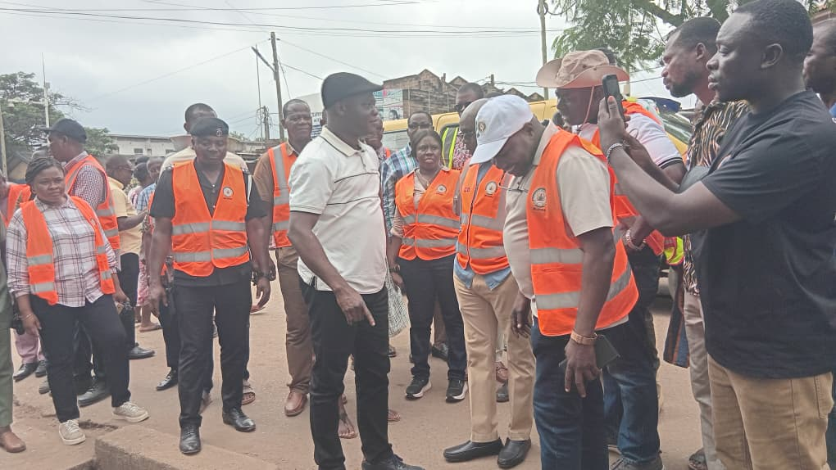
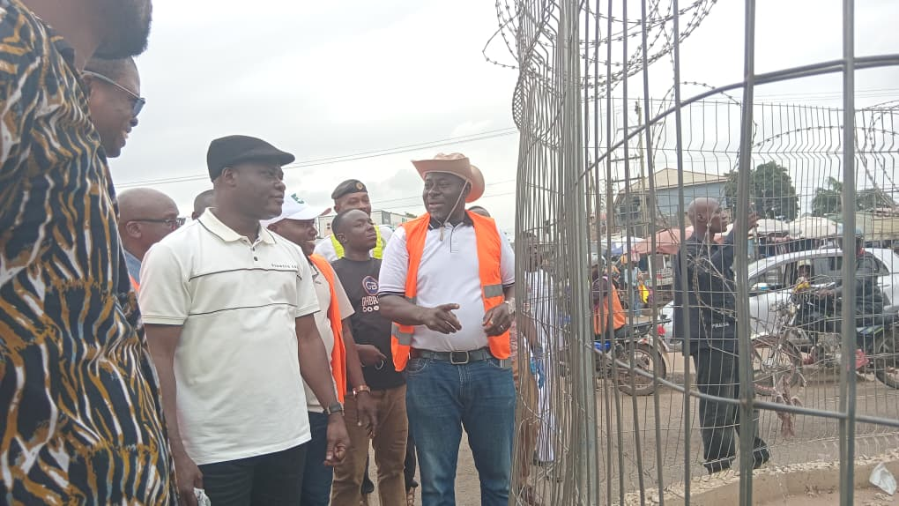

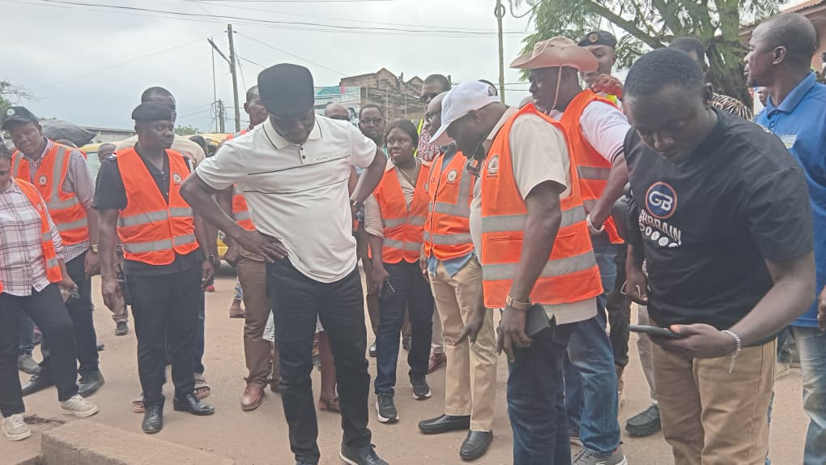
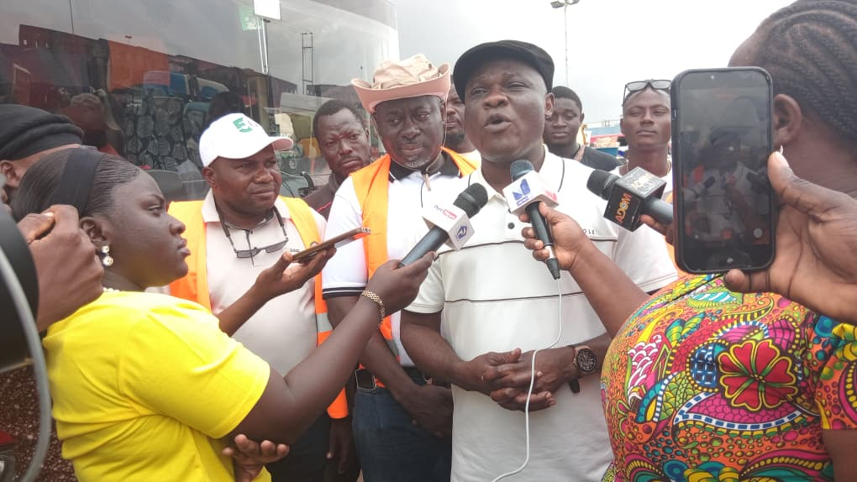

Maltiti Shememmah Siddiq
Intern- ISD

