Community Raises Concerns on Roads, Sanitation and Development during MCE's Visit to Pantang
Residents of Pantang (P&T Area) have appealed to the Municipal Assembly to address a number of pressing challenges affecting their community, including roads, sanitation, security, rate payment, and development control.
The concerns were raised during a community engagement with the Municipal Chief Executive (MCE), Hon. Ibrahim Faila Fusseini, and selected Heads of Department, who visited the area on Saturday, July 18, 2026, as part of efforts to interact with residents and gain first-hand knowledge of issues affecting the municipality.
A major concern raised by residents was the ongoing construction of the Pantang–Abokobi Road. While commending the road project, they appealed for the provision of bus stops and pedestrian walkways to improve public transport access and ensure the safety of pedestrians.
Residents also expressed concern about choked drains and storm water channels in residential areas, which they attributed to the ongoing road works. They called for immediate intervention to prevent flooding and protect public health.
On revenue mobilisation, community members highlighted challenges with property rate bills, noting that some bills did not bear the names of property owners, while others questioned the accuracy of the rates being applied. They appealed to the Assembly to rectify these anomalies to improve public confidence and compliance.
Sanitation also featured prominently during the engagement. Residents complained about the irregular collection of refuse by waste management companies, indicating that in some instances waste had remained uncollected for months. They also called for stricter enforcement of sanitation regulations to address the persistent problem of choked drains and indiscriminate waste disposal.
The community further raised concerns about security, reporting incidents of theft allegedly involving some motor riders and commercial motorcycle (Okada) operators. To improve safety, especially at night, residents appealed to the Assembly to install street lights in dark sections of the community.
On development control, residents expressed worry over the increasing incidence of unauthorized developments. They cited cases of buildings being constructed without the requisite permits, structures erected on road reservations, and unauthorized access roads being created. They also raised concerns about squatters putting up temporary structures in front of residential properties.
Addressing the gathering, the Municipal Director of Physical Planning, Mr. George Owusu Afriyie, urged property owners who had not regularised their building permits to do so without delay. He also advised residents not to permit squatters to erect unauthorized structures in front of their properties, stressing the need to protect planned developments and uphold planning regulations.
Responding to the issues raised, Hon. Ibrahim Faila Fusseini assured residents that the Assembly would work closely with the relevant departments and units to address the concerns. He reiterated the Assembly's commitment to improving infrastructure and service delivery across the municipality.
The MCE also encouraged residents to honour their rate obligations promptly, emphasizing that internally generated revenue remains essential for the Assembly to provide quality services and undertake development projects that benefit the community.
The visit forms part of the Assembly's ongoing community engagement initiative aimed at strengthening collaboration with residents, promoting accountability, and ensuring that development interventions respond to the needs and priorities of local communities.
Photo Recap: Last Saturday's Community Engagement
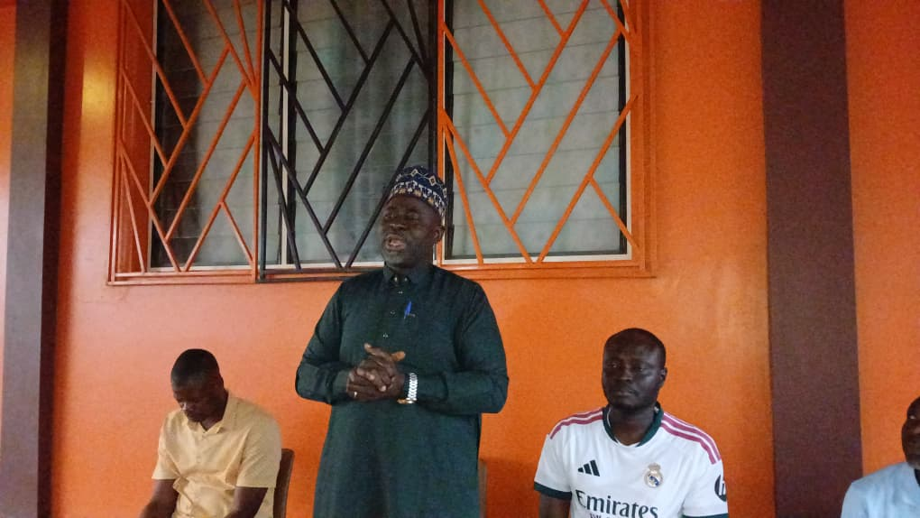

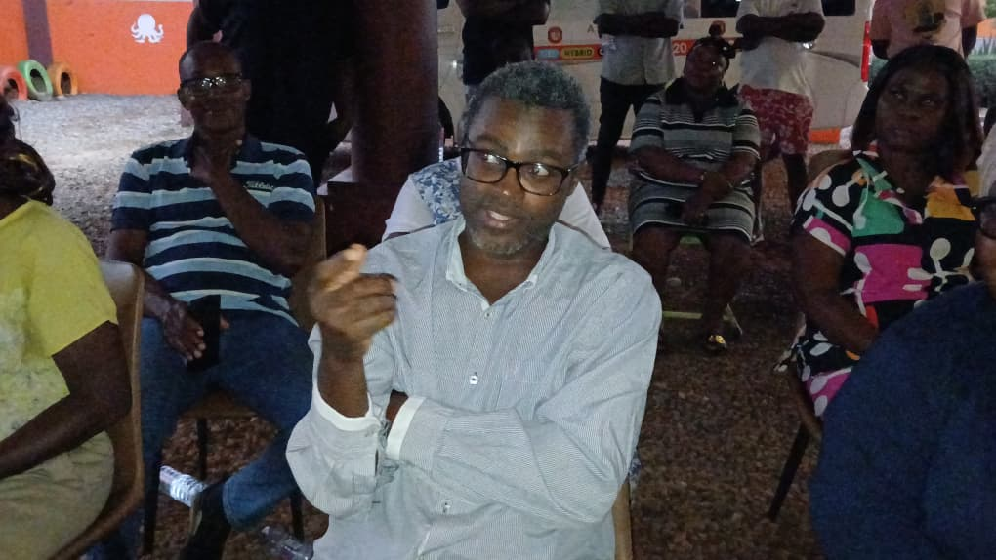
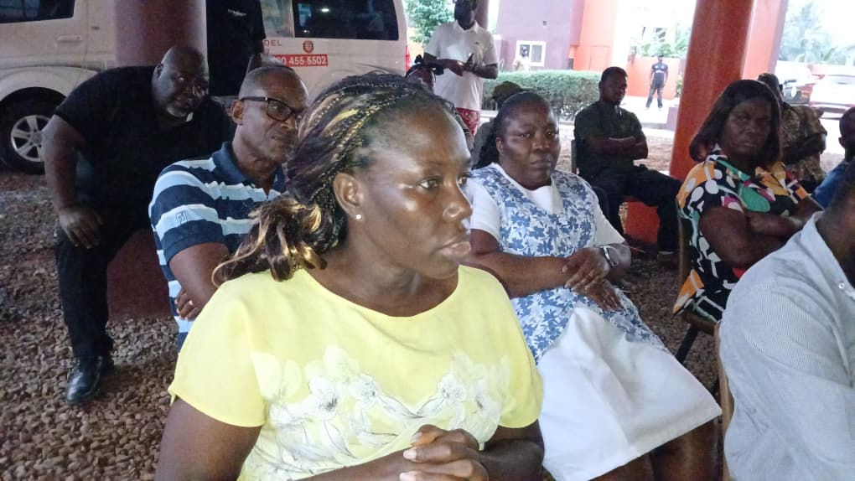

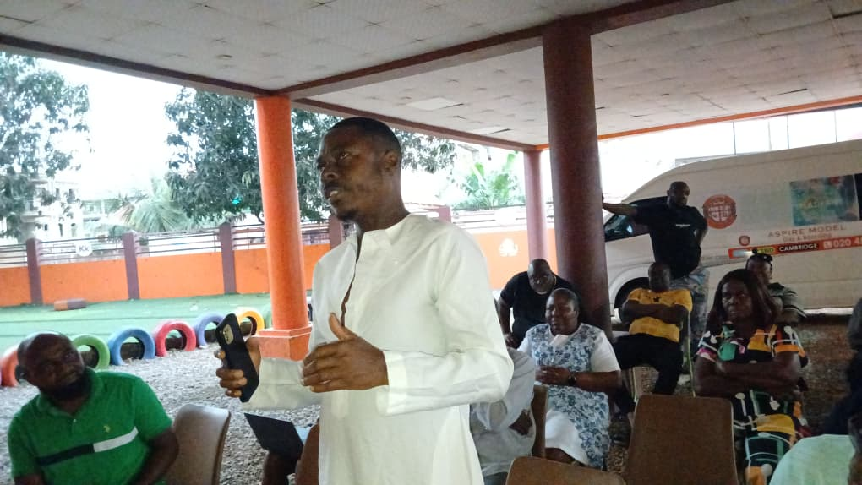

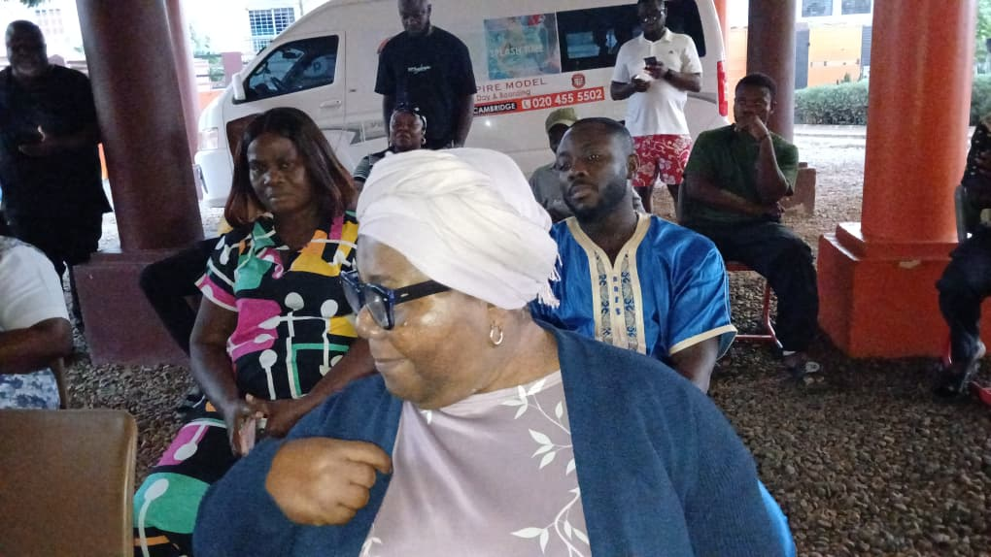

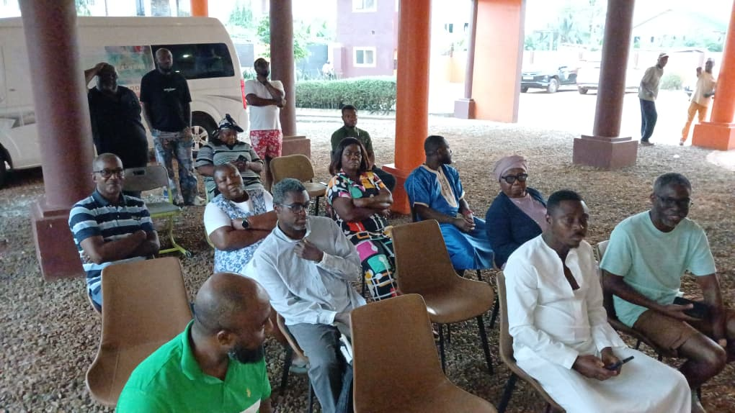



Maltiti Shememmah Siddiq
Intern, Department of Information
Madina Municipal Assembly

