LaNMMA Distributes Relief Items to Flood-Affected Communities

The La Nkwantanang-Madina Municipal Assembly (LANMMA), through the National Disaster Management Organisation (NADMO), has distributed relief items to residents affected by the recent floods in parts of the municipality on Tuesday, July 21, 2026.
The exercise forms part of the Assembly's commitment to providing immediate humanitarian assistance to households whose homes and properties were damaged by the floods, while supporting ongoing recovery efforts in the affected communities.
Addressing beneficiaries at the distribution exercise, the Municipal Chief Executive (MCE), Hon. Alhaji Ibrahim Fusseini Faila, assured residents of government's unwavering commitment to supporting victims of the disaster.
He noted that the relief items were intended to provide immediate assistance to affected families during this difficult period. However, he acknowledged that the items were not enough to meet all their needs and appealed to residents to remain calm as government, together with its partners, works to mobilise additional support for the affected communities.
Speaking to the media, the Municipal NADMO Coordinator, Mr. Anane Adjeigah, revealed that communities stretching from Danfa to Ayimensah were the hardest hit by the floods, recording extensive damage to homes and other property.
Mr. Adjeigah disclosed that the Municipal Directorate of NADMO had so far distributed relief items to more than 800 affected persons, while arrangements were underway to support the remaining 235 victims.
He explained that the distribution exercise is ongoing, adding that NADMO continues to mobilise resources to ensure that every affected household receives the needed assistance.
The relief items distributed included bags of rice, Frytol cooking oil, mattresses, blankets, mosquito nets, plates and cups to help alleviate the immediate hardship faced by the victims.
Beneficiaries expressed their gratitude to the Government, the Municipal Chief Executive and NADMO for the timely intervention. While commending the Assembly for the support, they appealed for additional assistance to help them rebuild their lives and recover from the devastating effects of the floods.
The La Nkwantanang-Madina Municipal Assembly reaffirmed its commitment to collaborating with NADMO and other stakeholders to strengthen disaster response, improve community resilience and safeguard the welfare of residents across the municipality.

The MCE, Hon. Faila, assisted by the Municipal NADMO Coordinator, Mr. Adjeigah, presents relief items to beneficiaries during the flood relief distribution exercise at Madina.
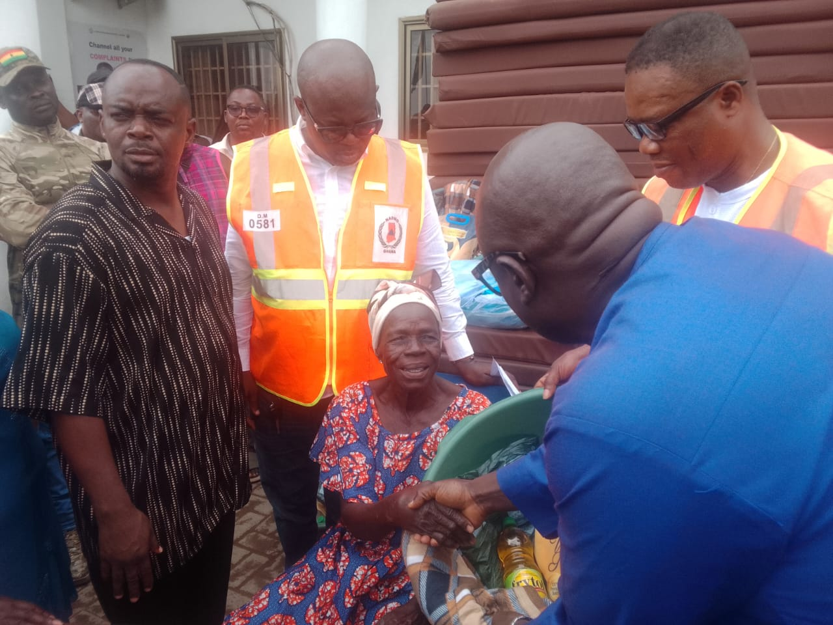
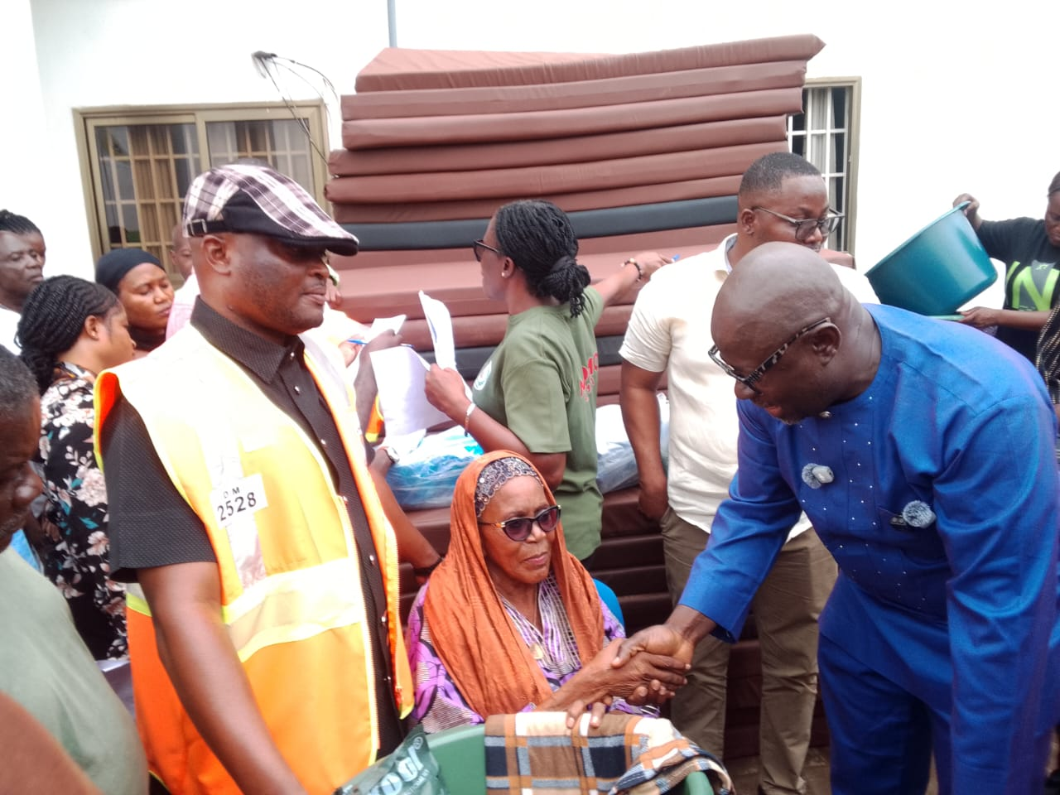
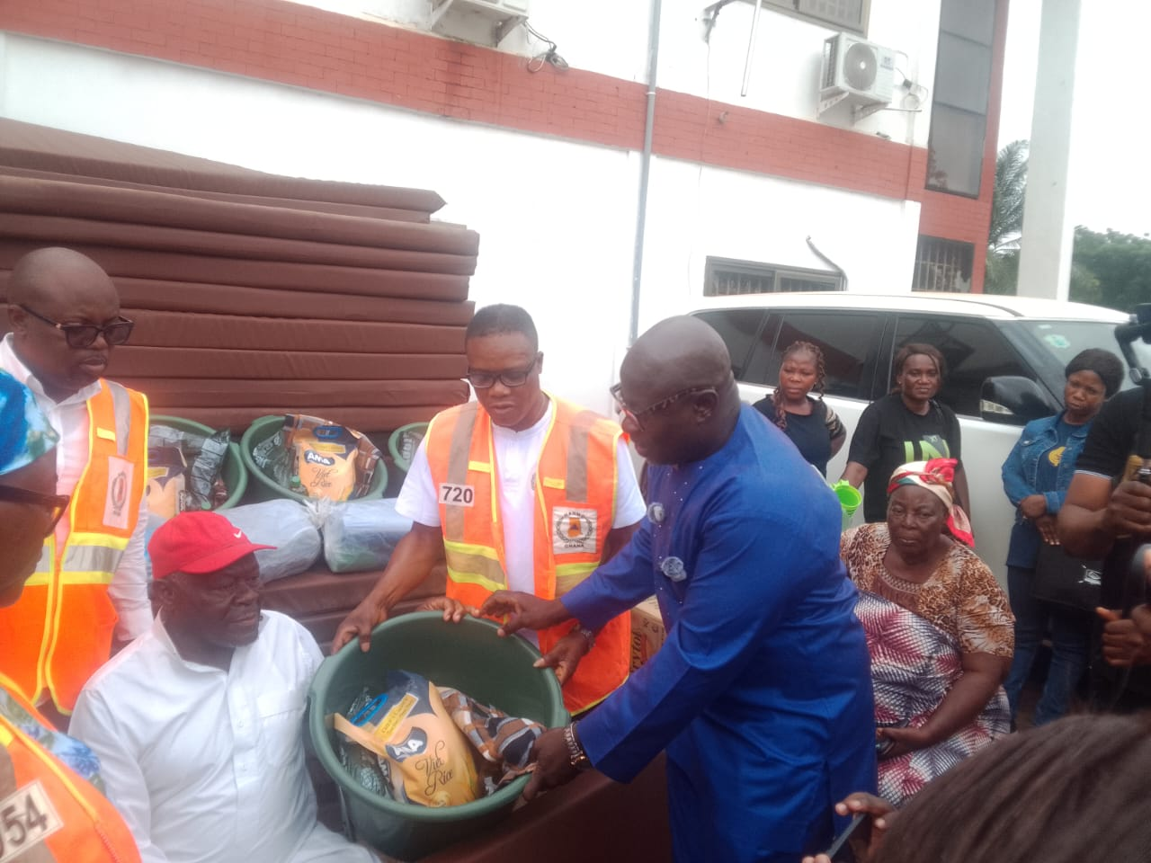

A cross-section of beneficiaries at the event.
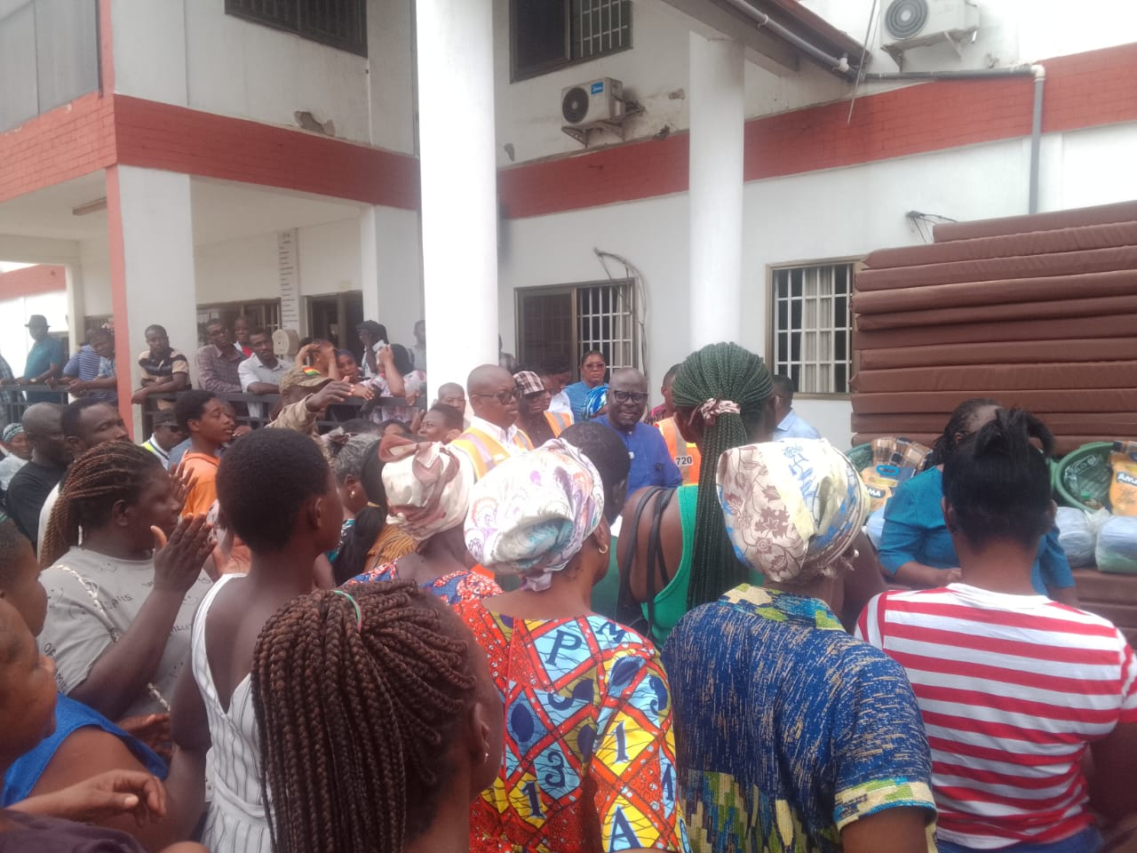

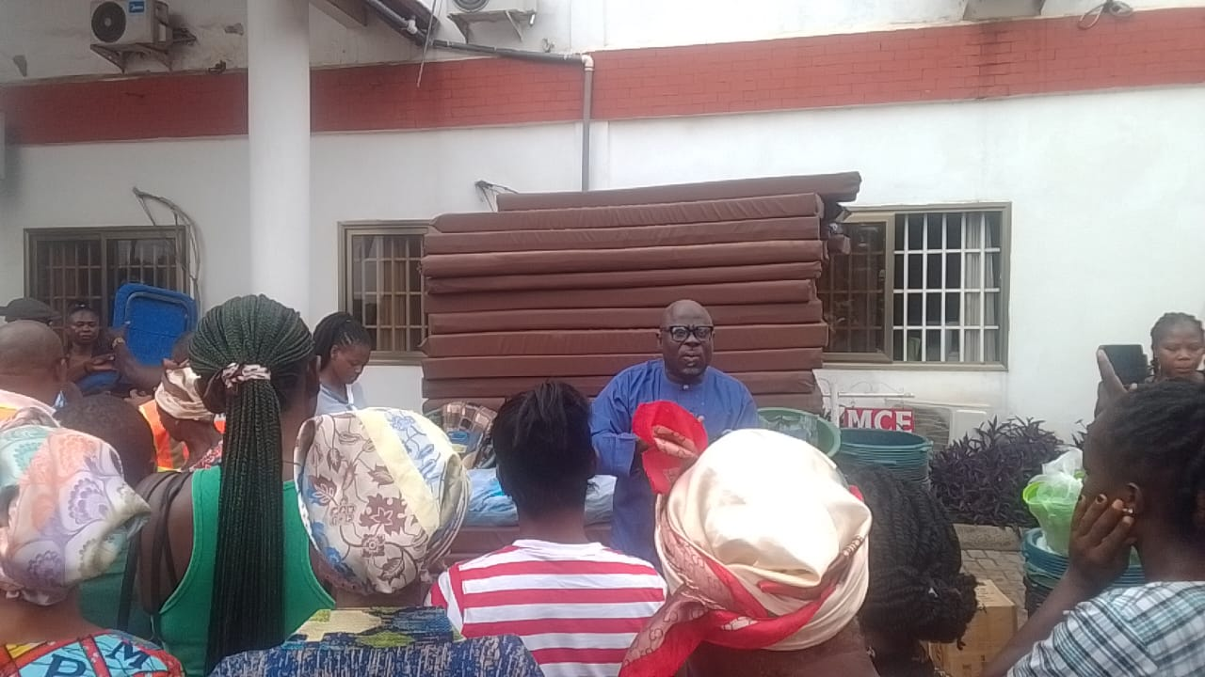

Maltiti Shememmah Siddiq

Intern, ISD

LaNMMA.

